Technical paper
Manufacturing Larch Tree Extract – Taxifolin (syn.Dihydroquercetin)
Brief introduction: About TAXIFOLIN
"ETALON COSMETICS" (Russian Federation) as a company grounded in science has dedicated years of research to learning about the science behind TAXIFOLIN to fully understand the extent of its benefits. "Etalon Cosmetics" producers and delivers non-GMO TAXIFOLIN, which is the polyphenol (class - dihydroflavonols) isolated from saw logs of larch tree.
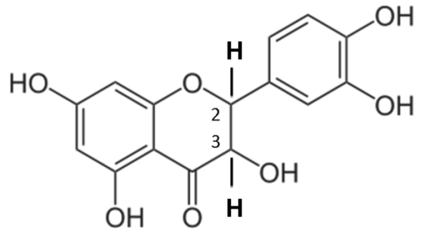

TAXIFOLIN is a safe, natural molecule with strong
antioxidant and anti-inflammatory activity, continued displaying a variety of health-promoting properties and modulating diverse biological functions making it a smart choice for consumers looking for an ingredient that offers “all-around” benefits. With more than 60 years of scientific research behind it, showing its benefits, this ingredient has the science to back its benefits.
TAXIFOLIN presents a unique molecule structural feature known as stereospecific, optically active that is chirality which distinguishes it from all other classes of polyphenols (flavonoids). Chirality (Engl. chirality, from Greek χειρ - hand) - lack of symmetry relative to the right and left sides. For example, if the reflection of an object in an ideal flat mirror differs from the object itself, then the object is inherently chirality. When used in a chemical context, the term "chirality" usually refers to molecules. Many biologically active molecules are chiral, including naturally occurring amino acids (the building blocks of proteins) and sugars.
This form of the Taxifolin molecule suggests the spatial arrangement of its functional groups (stereochemistry) with optically active (interaction with polarized light) functional components – enantiomers (or isomers), named (designated) according to the direction of light in which the plane of polarized light rotates, thereby defining Taxifolin molecule in a sub-class called flavonols, with another distinguishing feature in this sub-class, somehow the presence of a dihydro-functional group, thus defining the Taxifolin molecule as a monomer - dihydroflavonol. The generally accepted definition for the native form of the molecule is (2R,3R)-Taxifolin or Dihydroquercetin, or synonyms: (+)-Dihydroquercetin; (+)-Taxifolin.
Almost all dihydroflavonols such as Taxifolin (Dihydroquercetin) have two chiral carbon atoms in position 2 and 3. Taxifolin possess chiral centers at C2 and C3, and therefore have four possible stereoisomers (2R,3R – 2S,3S – 2R,3S – 2S,3R). (2R,3R) isomer of Taxifolin is the most common in nature, but there are cases where all four isomers co-occur. It should further be emphasized that, (2R,3R)-dihydroflavonols are homochiral.

The center of chirality is called R or S, based on the atomic number. If the center is oriented so that the priority of the substituent groups decreases clockwise, the name is R (Rectus), if it decreases counterclockwise, then S (Sinister). This system labels each chiral center of the molecule. The system can, for example, name an isomer (or enantiomer) in which the (R,R)-group is located opposite the (R,S) diastereomer. The R/S system has nothing to do with the (+/-)-system. The R-antiomer can be right-handed or left-handed, depending on the actual substituent groups. Isomers (or Enantiomers) (optical or mirror) are pairs of optical antipodes - substances characterized by opposite in sign and equal in magnitude rotations of the plane of polarization of light with the identity of all other physical and chemical properties (with the exception of reactions with other optically active substances and physical properties in a chiral medium).
Optically active Isomers (or Enantiomers) are identical with respect to ordinary chemical reactions, but differences appear when they are present in another chiral molecule or entity. Different isomers (or enantiomers) of chiral substances often have different odor and taste and therapeutic effects. For example of the four possible stereoisomeric forms of ascorbic acid, only one form (+)- ascorbic acid is identical to natural vitamin C, capable of prophylactic and therapeutic effects against scurvy, although all diastereoisomers of ascorbic acid have antioxidant properties.
Enzymes (and they are chiral) often differ between the two enantiomers of a chiral substrate. Imagine that the enzyme has a glove-shaped depression that binds the substrate. If the glove is right-handed, then one enantiomer will go in and bind, while the other enantiomer will not fit well and there is little chance of binding. The D-form of amino acids is usually sweet in taste, while the L-form is usually tasteless. Peppermint leaves and cumin seeds contain L-carvone and D-carvone, respectively, enantiomers of carvone. They smell differently because most people's olfactory receptors also contain chiral molecules that behave differently in the presence of different enantiomers.
Many chiral drugs are made in high enantiometric purity due to the side effects of the other enantiomer (which may even be inactive). For example: Ethambutol: One enantiomer is used in the treatment of tuberculosis, the other causes blindness. Naproxen: One enantiomer treats arthritis, but the other causes liver poisoning without analgesic effect.
Stereoisomers of Taxifolin are differentially distributed in the body. (+)-(2S;3R)-taxifolin is distributed intracellularly, (-)-(2R;3S)-taxifolin distributes extracellularly, while (-)- (2S;3S)- and (+)-(2R;3R)-taxifolin are deeply distributed into tissues. These findings suggest that the stereoisomers of Taxifolin exit the vascular system and are either distributed intra- or extracellularly or penetrate deep into tissues depending on their stereochemical configuration.
* Indicates chiral center * Indicates chiral center
Spatial isomerism (stereoisomerism) in the case of the Taxifolin molecule arises as a result of differences in the spatial configuration of molecules that have the same chemical structure. This type of isomer is subdivided into enantiomerism (optical isomerism) and diastereomerism. The process of interconversion of enantiomers is called racemization: it leads to the disappearance of optical activity as a result of the formation of an equimolar mixture of (-)- and (+)-forms, that is, a racemate.
Taxifolin molecule isomers
In practice, chemical transformations, as a result of which structural isomers are converted into each other, is called isomerization. Such processes are of great importance in the technological process of Taxifolin production, since intramolecular rearrangements leading to tautomerization (polymerization) of Taxifolin molecules are also isomerizations.
Therefore, methods for isolating Taxifolin (syn.Dihydroquercetin) and obtaining it close to its natural form require extremely “gentle” technological process conditions that exclude racemization and polymerization of molecule, while at the same time excluding the presence of any impurities in the form of fractions of larch oil, resin and their compounds, saponins associated with Taxifolin molecule.
Due to the strong tendency of Taxifolin molecule to form polymeric and aggregated forms with much lower biological activity, one of the main problems is the difficulty of obtaining a pure monomeric form free from polymeric forms and impurities. The fraction enriched with Taxifolin is usually isolated from larch wood (Larix sibirica, Larix Dahurica or Larix Gmelinii, L. cajanderi). With the help of extraction with alcohol and ether solvents (usually in the presence of acids, at pH 3-3.5) and subsequent multi-stage processing, it is possible to obtain Taxifolin single crystals and achieve a fairly high degree of purification from impurities - up to 96-98%. In industrial production, purification from impurities usually does not exceed 91-95%. In most cases, however, the contribution of the polymeric forms of Taxifolin itself remains unknown. Covalent polymerization of Taxifolin occurs very actively both during the life of a plant cell and during long-term extraction of Taxifolin and its storage. The presence of polymeric forms of Taxifolin in the preparations obtained is undesirable for two reasons: a) it is an extra ballast, b) it is a sorbent capable of lowering the effective concentration of Taxifolin itself (monomeric form) and other active substances (when used as part of dietary supplements and drugs) - due to their sorption on polymers.
Taxifolin polymer

The technology of extraction (obtaining) of the native form of the Taxifolin molecule involves strict adherence to various physico-chemical parameters, for example, solvents, acidic and alkaline environments, temperature conditions, pressure, density, and others. However, various technological processes are used in practice, as a result of which the shape of the Taxifolin molecule is more consistent with the diastereomeric and racemate forms, which are not optically active enantiomers, moreover, represented by polymer formations caused by tautomerization. An example of such technological solutions is the wood chemical industry using ethyl acetate and alkalis.
The result of excessive polymerization of Taxifolin molecule is poor solubility, absorption in the body, lower biological activity, rapid degradation by the microflora of the gastrointestinal tract to aromatic acids. The racemic form of Taxifolin (mixture of its isomers) does not have the biological activity of the native form. Thus, Taxifolin presented by various manufacturers suggests different biological activity, in particular antioxidant acitivity which can vary from batch to batch, even inside of one batch.
Although little was known about chirality in Lewis Carroll's day, his work Alice Through the Looking-Glass contains a prescient reference to the various biological activities of enantiometric biological substances: "Maybe the looking-glass milk is not drinkable," Alice said to her cat.

Quality Control – Initial RAW MATERIAL
"Etalon Cosmetics" – manufacturer, produces Taxifolin from raw or so-called dirty Taxifolin obtained from a qualified suppliers. Despite this fact, the manufacturer exercises direct control over the supply of the original raw material - the butt logs of larch, since there are features of the content of extractives, including Taxifolin, in different species of larch. Preference is always given to raw materials obtained from Daurian larch. Dahurian larch the ether-soluble extractives amounts to 0.7-1.8 % and the phenolic nature ethanol-water-soluble extractives such as mainly dihydroquercetin to 1.8-6.3 % (Terziev 2002b). The dominant flavonoids found are quercetin (11 % of the total amount flavonoids), Taxifolin or Dihydroquercetin (69 %) and dihydrokaempferol.
Siberian Larch
Dahurian or Gmelinii Larch
The largest potential source of soft-wood logs for structural lumber in the world is Russia. It is estimated that growing stock east of the Ural Mountains is about 40 billion m3 and one third of this is larch. Of this larch, about 56 percent is dahurian larch (Larix dahurica or Gmelin larch) growing in an area equivalent to six times the state of Oregon.

In the production of raw or dirty Taxifolin, both Siberian and Dahurian larch are used, which differ slightly in Taxifolin content, and more importantly, differ sharply in larch resin and oil content. More Taxifolin, less cost. More resins and oil means a sharp rise in the cost of Taxifolin production. That is why Dahurian Larch is preferable.
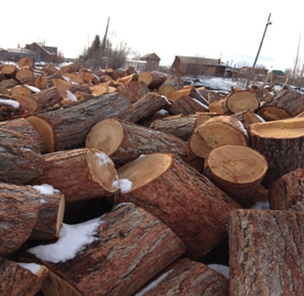
Harvesting of raw materials from larch always takes place during the cold period of the year, since the content of Taxifolin is 1.5-2 times higher. The usual temperature background during the harvesting period is minus 25 to minus 50 degrees Celsius. Periodically, specialists travel to the places of procurement for the qualification of raw materials.
Used as raw material – part of the tree: saw logs. The saw logs of larch trees are considered to be the waste products of wood or logging industry.
HTS code: 4401 10 000 0 fuel wood.
RAW MATERIAL: PRE-QUALIFICATION
1. The butt logs must be harvested only in a winter season beginning October until May;
2. The age of the Larch used for butt logs to be over 100 years;
3. Moisture content: 18-23 % (semi dry), maximum 30% (raw);
4. Butt log’s height to be not over 80 cm from earth level; 5. Diameter to be from 30 up to 50+ cm, excluding bark;
6. Annual ring width 0.4-0.5 мм, 0.5-0.6 мм, 0.6-0.7 мм, 0.8-0.9 мм, 0.9-1.0 мм
In the production of raw or dirty Taxifolin, in which the content of Taxifolin itself varies from 65% to 85%, larch oleoresin (resin and oil, terpene, saponins) is always present and it is extremely important that this ballast is present in a smaller amount for the efficiency of further purification of Taxifolin.

In the raw or dirty Taxifolin this ballast means after the group separation of the larch wood oleoresin, 12.5% of monoterpene hydrocarbons, 0.75% of sesquiterpenes, 18% of diterpene hydrocarbons and aldehydes, 13.5% of diterpene alcohols, and 32.5% of resin acids were obtained. The qualitative and quantitative analysis of the monoterpenes established that the monoterpene fraction contained: a-pinene (20.5%), camphene (0.3%), 8-pinene (23.2%), 3-carene (49.8%), myrcene (0.3%), limonene (1.1%), and 8-phellandrene (2.3%). In the sesquiterpenoid fraction we identified 16 compounds: cyclosativene, longicyclene, alfa-longipinene, sibirene, longifolene, y-elemene, a,y and e-murolenes, beta-selinene, d-, y-, and e-cadinenes, a-humulene, calamenene, and the methyl ether of thymol, the main components being delta- and gamma-cadinenes and longifolene. From the fraction of diterpene hydrocarbons and aldehydes presented by dehydroabietane, a mixture of dehydroabietinal and abietinal and palustral. By chromatography of the diterpene alcohols were determined epimanool, larixyl acetate, and larixol. The analytical GLC of the mixture of resin acid methyl esters showed the presence in them of the esters of the acids palustric and (or) levopimaric (7.2%), isopimaric (86.2%), dehydroabietic (2.0%), abietic (4.6%), and neoabietic (traces).
Many of these components have significant biological activity as well as toxicity to our body. Therefore, an extremely important task is to get rid of ballast - larch oleoresin when purifying raw Taxifolin. The manufacturer's specialists constantly monitor qualified raw taxifolin suppliers for both taxifolin content (should be at least 80%) and oleoresin content, including Larch saponins (source larch oil) most often contain abietic and dehydroabietic acids as aglycones. Saponins are the sugar moiety inside of which the aglycone – molecule is contained. Samples are taken from each batch of raw Taxifolin.

Botanical material, affecting the quantity and spectrum of components in a larch tree extract
Parameter | Quantity of extract (native extract ratio) | Spectrum of components
1. botanical material  type  plant part  water content  grade of comminution | +  +  +  # no influence provided that steady-state or exhaustive extraction is reached | +  +
Type and plant part, both parameters can significantly impact on quantity of extract and spectrum of components, these parameters are always same in deliveries of raw material. Water content can be decreased following by long storage of already debarked larch saw logs and more pronouncedly decreased due to even short term storage of already cut of debarked logs into four parts. Grade of comminution is always the same.
+ This parameter impacts on the quantity of extract or the spectrum of components.
Botanical Source: Not genetically modified plant of genus Larix of conifers in the family of Pinaceae: Larch species: L. dahurica L., L. gmelinii, L. sibirica ledeb., L. cajanderi, L. czekanowskii, L. russica, L. sukaczewii. Used part: saw logs, debarked. The saw logs of larch trees are considered to be the waste products of wood or logging industry. Primarily botanical material used for extraction used to be larch wood chips.
Without a doubt, the polyphenol Taxifolin can be extracted from various plant materials, for example, from milk thistle or oregano, however, the molecular forms of Taxifolin have a strong bond with various sugars (arabinose, rhamnose), the so-called Taxifolin (Dihydroquercetin) glycosides or with coniferyl alcohols, as in milk thistle. The bioavailability of such forms is extremely low, due to the lack of chirality, stereospecificity of the molecule, inherent only in Taxifolin from larch, where molecule is not firmly linked via H-bonds with another molecule of other compounds. In addition, due to the high content of the ingredient in the butt portion of larch, other plant raw materials require large plantations for the collection of raw materials and extraction.

Quality Control – RAW TAXIFOLIN
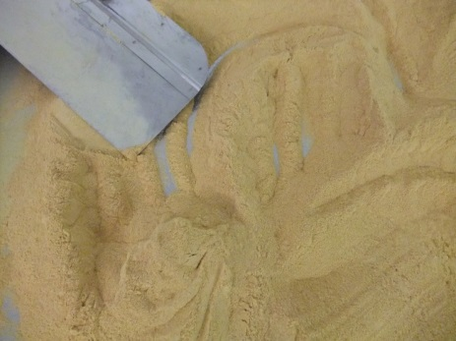
As soon as the raw Taxifolin arrives for further purification, a procedure for checking the identity and content of Taxifolin is carried out. Only after these procedures the raw Taxifolin passes freeze drying in order to remove mostly the ballast – larch oleoresin.
Soluble in ethanol, propanol-2, acetone, sparingly soluble in butyl acetate and hot water (70°C), very slightly soluble in water, practically insoluble in chloroform.

Raw TAXIFOLIN
Authenticity.
Qualitative sample.
0.02 g of crude Taxifolin (TX) is dissolved in 1 ml of 95% ethanol, and 0.5 ml of concentrated hydrochloric acid and 0.05 g of magnesium chips or magnesium powder are added to the resulting solution. A red color appears.
UV spectroscopy.
About 0.05 g of the ingredient, dried at a temperature of 105 ° C for 1 hour, is dissolved in 70 ml of 95% alcohol in a volumetric flask with a capacity of 100 ml, the volume of the solution is adjusted to the mark with 95% alcohol and mixed.
1 ml of the obtained solution is transferred into a volumetric flask with a capacity of 50 ml, the volume is adjusted to the mark with 95% alcohol and mixed. The UV spectrum of the solution in the wavelength range from 230 to 380 nm has an absorption band with a maximum at 290+2 nm, a minimum at 250+2 nm, a shoulder at 330+2 nm.
Weight loss on drying.
About 0.5 g of the ingredient (accurately weighed) is dried at a temperature of 105 ° C for 1 hour. The loss in mass should not exceed 8.0%.
Sulphated ash and heavy metals.
Sulphated ash from 1.0 g of the ingredient (accurately weighed) should not exceed 0.3% and must pass the test for heavy metals (no more than 0.001%).
Quantitative determination of the main substance – Raw Taxifolin (TX).
3.6.1. HPLC Method
About 10 mg of powder (accurately weighed) of an average sample of raw TX, previously dried at a temperature of 105 ° C for 1 hour, is dissolved in a certain amount of acetonitrile to obtain a solution with a concentration of 1 mg per 1 ml. The solution is thoroughly mixed.
The analysis is carried out by HPLC.
2.0 µl of the solution is injected into a Milichrome-4 or Milichrome-5 liquid chromatograph with a UV detector and a reversed-phase column and chromatographed under the following conditions:
Column - 64 mm x 2.0 mm Sorbent - Separon C18 Analytical wavelength - 290 nm
Mobile phase - 30% acetonitrile in 2% acetic acid Mobile phase flow rate - 100 µl/min
Chromatogram recording time - 9 minutes
Peak areas in chromatograms are determined using an electronic integrator. Under the same conditions, chromatography of the solution of the Reference \ Standard Sample of Taxifolin is carried out in parallel.
Measure the peak area of Taxifolin on the chromatogram of the test solution and the peak area on the chromatogram of reference/standard of Taxifolin.
The content of Taxifolin in the raw Taxifolin powder (A) is calculated by the formula (1):
S1
A = ______ 100% (1), where
S2
S1 is the area of the peak of Taxifolin on the chromatogram of the test solution; S2 - Taxifolin peak area on the chromatogram of reference/standard solution;
The content of Taxifolin must be at least 70%.
Notes:
1. Preparation of the mobile phase.
To 300 ml of acetonitrile “for liquid chromatography” add 700 ml of 2% acetic acid solution and mix.
The shelf life of the solution is 1 month.
2. Preparation of a 2% solution of acetic acid. Place 19 ml of acetic acid “ice” in a 1 liter volumetric flask, bring the volume with distilled water to 1 liter and mix.
The shelf life of the solution is 1 month.
3. Preparation of a solution of reference/standard Taxifolin. About 10 mg (accurately weighed) standard of Taxifolin, previously dried at 105⁰C for 1 hour, is dissolved in a certain amount of acetonitrile to obtain a solution with a concentration of 1 mg per 1 ml.
The shelf life of hermetically sealed solution is 1 month.
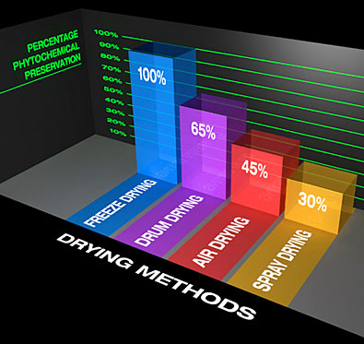
The absorption spectrum of ring C of Taxifolin molecule is 254 nm. with a given UV absorption band, it is possible to determine how much product with impurities is in the commercial product raw Taxifolin, which is very important for assessing steps and adjusting parameters of freeze drying.
TECHNOLIGICAL PROCESS of purification of RAW TAXIFOLIN
"Etalon Cosmetics" produces Taxifolin from raw or so-called dirty Taxifolin obtained from a qualified suppliers. After freeze drying of raw Taxifolin (70%) when the larch oleoresin is partially removed, the product with 80-85% of Taxifolin can be purified.
Technological process relates to chromatographic extraction of (2R, 3R) – Taxifolin achieving the minimum purity 92%, whereas the rest of content are relative flavonoids: 1/ Dihydrokaempferol (or trade name Aromadendrin), belongs to dihydroflavonols family; 2/ Naringenin; 3/ Quercetin; 4/ Eryodictiol (traces); 5/ Caffeic Acid (phenolic compound). It is possible to produce this isomer (enantiomer) of Taxifolin up to 98% purity by removing mentioned healthy ingredients (flavonoids) know on the market. Is it a sense? Anyway, this is a matter of the order and will cost additional money.
Obviously, there is a content of water 1.5% up to 3%. Some manufactures has the water content up to 12%. Molecules of water are bounded with molecules of Taxifolin making it crystal. On the market can be made some misunderstanding when Quercetin Hydrate is confused with Dihydroquercetin (Taxifolin). This is a mistake.
Quercetin Hydrate this is Quercetin crystal with water inside, however Dihydroquercetin (Taxifolin) depicts distinguishing feature in this sub-class, somehow the presence of a dihydro-functional group, thus defining the Taxifolin molecule as a monomer - dihydroflavonol.
The objective of acquiring highly pure Taxifolin is achieved by dissolving raw material containing Taxifolin in water solution of ethanol, having concentration of 30% at temperature of 25-29°C, wherein the content of Taxifolin reaches up to 250 g/L, followed by chromatographic separation under pressure of 100-500 kg/cm2 on a column with dynamic axial compression filled with reverse-phase sorbent, having increased retention of polar bonds, particle size from 10 to 20 microns, pore size from 120 to 200 A. The sorbent is eluted with previously degassed and modified water solution of ethanol, the eluat fractions are gathered by means of refractometric and mass spectrometric analysis, which is followed by crystallization by freezing, filtering and lyophilisation of the target product - only the (2R,3R)- taxifolin (or dihydroquercetin) with the full absence of its optical stereoisomers.
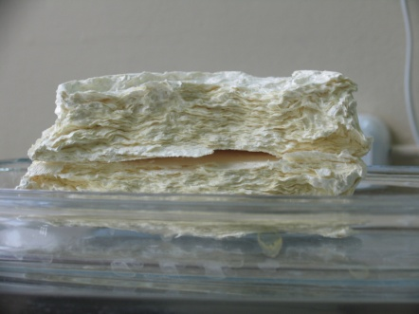

The eluat is modified preferably with methanol, isopropanol, acetic acid, formic acid, until the presence of these elements in the eluat reaches 0,001 - 5 % by volume.
The range of concentration values of ethanol and range of volume values of Taxifolin in the obtained solution, described above, were chosen in accordance with the condition of the maximum capacity of the process, taking into consideration the different solubility of the primary technical (raw) Taxifolin and its admixtures (impurities or contaminants). The advance degassing of the initial water and alcohol solution of Taxifolin and the eluat, allows to avoid the oxidation, caused by dissolved oxygen of the target product and considerably increase the precision of refractometric and mass spectrometric determination of (2R,3R)- taxifolin (dihydroquercetin) in the eluat, which in turn allows to increase production capacity, purity and output of the product.
The range of pressure values, 100-500 kg/cm², during the chromatographic separation is determined by the preparative column YMC DAU 100-700 with dynamic axial compression using a reverse-phase sorbent having increased retention of polar bonds YMC ODC-AQ-HG, sorbent having particle size from 10 to 20 microns, size of pores from 120 to 200 A. The latter were determined in accordance with the nature of the target product and related to the possible presence of three Taxifolin stereoisomers having different polarity then (2R,3R)- taxifolin (dihydroquercetin), as well as in compliance with the maximum rate of 150 - 250 ml/min at which eluat is supplied.
It is crucial to maintain the temperature within the range of 20-29°C during the process of dissolving the initial Taxifolin and its chromatographic separation. The capacity of the process decreases substantially if the temperature falls below 20°Cand the rise of temperature above 29°C increases the risk of stereo isomerization of the target product.
The gathering of eluat fractions by means of simultaneous refractometric, spectrometric and mass spectrometric analysis allows reusing the solvent from the eluat without a thorough distillation of the column; ensures more precise analysis of fractions with the molecular weight within the range of 100 - 1000 units; and also allows isolating relative flavonoids separately to obtain pure target products. These procedures allow to increase the output of the Taxifolin up to 98 %.
Ethanol and water is removed from eluat fraction, acquired by chromatographic isola- tion, by using Hei-VAP Value HB/G3 Heidolph rotor of the plate-rotor pump in the vacuum at a temperature of 30°C. The solvent from remaining fractions is distilled by using Laborota 20 (LR 20 eco) rotor.
The obtained (2R, 3R) – taxifolin (dihydroquercetin) is transferred to the lyophilizer, wherein special containers with (2R, 3R) – taxifolin (dihydroquercetin) are automatically sealed after drying in deep vacuum at a temperature of -55°C.

The chemical purity of Taxifolin is controlled directly during the chromatographic analysis when the flow of eluat is split and directed to fraction collector and detectors by means of a guide. The refractometric, spectrometric and mass spectrometric detectors are used simultaneously. The product is additionally checked for the content of polymers (polymer forms of Taxifolin or high weight molecule fractions), using a gas-vapour osmometer K-7000 KNAUER.
The antioxidant activity is assessed by spectrofluorometer FLUOstar Optima in accordance to the known method ORAC.
Additional Quality Control – Monomer / Polymer ratio
Methods for monitoring the purification of Taxifolin (TX) are not sensitive enough, especially when it comes to the detection of micromolar amounts of polymers. For the detection of Taxifolin polymeric macromolecules, were used two express methods: UV spectrophotometry (in combination with filtration) and Rayleigh light scattering (with using a spectrofluorimeter with crossed monochromators).
The Taxifolin concentration was determined by weighing and UV photometrically at 330 nm in 1-cm quartz cuvettes in a standard compartment on an M-40 spectrophotometer (Germany). The contributions of the ionized (monomeric) form and non-ionized monomeric and polymeric forms were found from the absorption spectra in the range of 250–400 nm.
The intensity of weak Rayleigh light scattering was measured at a right angle on an SLM-4800 spectrofluorimeter (USA) with crossed monochromators (slits - 4 nm) set at a wavelength of 530 nm. This highly sensitive scatter measurement method has recently been used to detect aggregates of denatured insulin. Taxifolin solutions were placed in standard transparent 1-cm cuvettes at 17°C. Each point was recorded in the 6-second accumulation mode.
High Molecule Weight Polymers (HMWP) was removed by filtering the DHA solution through millipore filters made of various materials (Millex GV, Millex HP, Millex GP, Flow-pore-D, FP, etc.) with four characteristic pore diameters: 0.45 microns, 0.22 microns, 0.1 micron and 0.05 micron.
Taxifolin in aqueous solution had two intense UV absorption bands - with maxima in the region of 290 and 330 nm. Based on the well-known Bouguer-Baer light absorption law, it was determined that the molar extinction coefficient of Taxifolin at 330 nm is 2×104 M-1 cm -1. This band entirely belongs to those Taxifolin molecules, where the phenolic hydroxyl groups are ionized. The band at 290 nm belongs to nonionized Taxifolin. Moreover, it should be noted that at 290 nm, not only monomeric but also polymeric forms of Taxifolin are absorbed, because polymerization is carried out mainly by covalent bonding through phenolic hydroxyl groups.
It turns out the standard +/- 2R3R - Taxifolin, and Taxifolin with all fractions is found on ring B, very simply
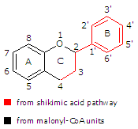
A stereospecific, chiral Taxifolin molecule. * - centers of chirality

The maximum absorption spectrum of the all fractions of Taxifolin molecule at the UV absorption band of 290 nm, namely, the absorption by ring B, the exact part of the molecule formed from shikimic acid along the shikimate pathway of development

The band at 330 nm belongs predominantly to the monomeric form of Taxifolin, while the band at 290 nm belongs to both monomeric and polymeric forms. Indeed, when a Taxifolin solution is filtered through millipore filters with different pores, the intensity of the band at 290 nm noticeably decreases, while the intensity of the band at 330 nm does not change or changes little. For example, in the case of filtering a solution of 94 μm Taxifolin through a 0.45 micron Flow-pore-D filter, the intensity of the band at 290 nm decreased by half, and when using a 0.1 micron filter, it almost tripled compared to the original. The filtration process through a 0.45 micron filter takes about 1 minute.
Thus, the use of millipore filters allows efficient express purification of the Taxifolin fraction from its polymeric forms.
From the ratio of the areas of the bands at 290 and 330 nm and their changes after filtration, it follows that the amount of polymers in the Taxifolin product used (Russian manufacture) is very high, contrary to the 96% degree of purification declared in the certificate. The proportion of polymers larger than 0.45 microns is at least 30%, and more than 0.1 microns - about 10% of the total amount of Taxifolin.
The degree of filtration purification of Taxiolin from HMWP was found from the data on the change in optical density (D). Filtration through a 0.05- or 0.1-micron filter gives a noticeably greater degree of removal of polymers than through a 0.45-micron or 0.22-micron filter, but takes slightly longer.
It should be emphasized that the size of the HMWP refers to the length of the polymer. The thickness and width of the Taxifolin polymer macromolecule are negligibly small (on the order of 10 Å). Indeed, all solutions were cloudy, completely transparent (spectral lines in the region of 380-400 nm, where Taxifolin does not absorb, are close to the abscissa), i.e. large amounts of polymer particles and aggregates with an effective diameter of more than half the wavelength of the light wave are not detected spectrophotometrically.
However, there are still aggregates in the Taxifolin preparation (in a small amount). This is evidenced by the fact that when diluting the Taxifolin solution (previously filtered through a 0.45 micron filter) by 2.5 times, the ratio of optical densities at 290 and at 330 nm decreases to varying degrees: the band at 330 nm decreases by 59%, and at 290 nm - only by 41%. Aggregates make up (under given conditions and concentration) about 5-10% of all Taxifolin molecules. It is difficult to determine the contribution of aggregates with greater accuracy, since the extinction coefficients of Taxifolin in polymer macromolecules and their aggregates are unknown. In such macromolecules and their aggregates, screening hypochromism usually occurs - a decrease in the average extinction coefficient per chromophore due to the competition of stacked chromophores for a photon covering them in one wave train.
By measuring Rayleigh light scattering with a highly sensitive method - on a spectrofluorimeter with crossed monochromators - it is possible to detect polymeric and aggregated forms even at very low concentrations. In the area from 3 to 94 μm Taxifolin there is an almost linear relationship between the concentration of the substance and the intensity of light scattering. It should be emphasized that there is no Rayleigh scattering on monomeric Taxifolin molecules, since the size of these molecules is many hundreds of times smaller than the wavelength of light. On polymer macromolecules and their aggregates, if they have an effective diameter of more than half the wavelength, Rayleigh light scattering takes place.
It should be noted that measurements of light scattering on a spectrofluorimeter were not complicated by fluorescence, since Taxifolin practically does not fluoresce (unlike its closest analogue, Quercetin). In addition, at 530 nm Taxifolin has no absorption band at all.
With an increase in the concentration of Taxifolin more than 94 μm, there is a slight decrease in light scattering. This seemingly paradoxical fact is explained by the fact that, at high concentrations, macromolecules of polymeric Taxifolin begin to “stick together” in pairs, i.e. the number of scattering particles decreases.
After filtering the Taxifolin solution, the intensity of light scattering and the fluctuation amplitude sharply decrease. The maximum effect occurs when using a filter with a minimum pore size of 0.05 microns. The filtration process took about 4 minutes.

Additional Quality Control
In the Taxifolin molecule, as previously mentioned, an important role is played by chiral centers (2* and 3*), the presence of strong intramolecular hydrogen bonds (H-2 and H-3 protons). However, like other forms of flavonoids, Taxifolin molecule can also be in the form of a glycoside, when varieties of sugars or various impurities in the form of saponins (a type of sugars), other toxic elements are attached to the hydroxyl group in position R7 (ring C).
The absorption spectrum of ring C is 254 nm. With a given UV absorption band, it is possible to determine how much product with impurities is in the commercial product Taxifolin, which is very important for assessing potential biological activity.
In custody
Now that Taxifolin is understood, the proper structure of the molecule is understood, we must determine how the ingredient should be used, specifically consumed. Through the use of transcription factors as tools to study gene-regulated networks, we aim to determine how cell protein machinery decodes genetic information, is controlled during normal human development and growth, and how deregulation in gene expression leads to diseases such as like diabetes, cancer.
Taxifolin molecule, namely its metabolites, can modulate the expression of several genes, including those encoding detoxification enzymes, intracellular circulating proteins, cell growth factors, and DNA repair proteins. Taxifolin significantly activates the induction of transcription factors, which are called antioxidant response elements (ARE). A total of 65 genes, including several detoxifying enzymes (NQO1, GSTM1) and an antioxidant enzyme (thioredoxin reductase1), were activated by the TX molecule at 60mg.
The recognition sites of inducible transcription factors are called response elements and, as a rule, the same response elements are contained in the structure of the flanking sections of genes encoding functionally similar proteins. Due to this distribution of response elements and activation of inducible transcription factors, under the conditions of one or another influence in the cell, a coordinated rearrangement of the expression of a whole group of genes occurs, which leads to an increase in the intracellular amount of proteins that counteract the effects of negative factors.
So, how can dietary ingredients like Taxifolin normalize these expression patterns, i.e., how can we normalize altered gene expression patterns into various bodily states or forms closer to more normal expression using targeted nutrients.
Taxifolin "has" a regulating and modulating effect on the key functional systems of cells, organs and tissues of the body, including: the antioxidant system of cells and tissues; enzymatic systems, including representatives of almost all classes and groups of enzymes (oxido-reductase, hydrolases, lyases, transferases, kinases); receptor apparatus of cells and intracellular information systems; systems of ion transport and ion homeostasis of the cell.
There are six main factors that affect both the expression pattern of our genes and the genome as a whole: food, diet, physical activity, stress levels, bad habits, environment (ecology). Moreover, many of these interactions between the genome and the environment are epigenetic.
TAXIFOLIN-RICH EXTRACT 92% purity assay ( manufacture "Etalon Cosmetics", Russian Federation) ORAC Using Multiple Radicals (ORAC-FN): New Horizons in Total Antioxidant Capacity Measurement.
ORAC_{FN} Test by Brunswick Laboratories, INC (USA)
Antioxidant Power Result ( μmole TE/gram )
Against Peroxyl Radicals | 23 075
Against Hydroxyl Radicals | 32 873
Against Peroxynitrite | 975
Against Super Oxide Anion | 7 228
Against Singlet Oxygen | 2 795
Total ORAC_{FN} | 66 946
TAXIFOLIN has the highest ORAC value among botanical antioxidants. TE - Trolox® (a water-soluble analogue of vitamin E) as a standard by which all other antioxidant compounds are compared.
Cellular Antioxidant Assay CAA TAXIFOLIN-RICH EXTRACT / Test by Brunswick Laboratories, INC (USA) /
Results:  Description |  |  |  |  | Test |  |  | Result
EC50 CAA
TAXIFOLIN rich extract “Etalon Cosmetics” |  |  | CAA | 61.17 |  | μg/mL | 437.77 |  | μmole QE/gram
Cellular Antioxidant Assay measures intracellular antioxidant levels and inhibition of oxidation.
It is a preclinical measure of bioavailability that describes the amount of a substance to be absorbed by cells as well as its antioxidant effectiveness within the cell. Quercetin is used as the standard, and the results are expressed as μmole quercetin equivalency per gram (or milliliter) of a tested material.
Cellular Anti-Inflammatory Assay (NFkB) TAXIFOLIN-RICH EXTRACT / Test by Brunswick Laboratories, INC (USA) /
Results: Description |  | Analysis | Inducer/  Stressor | Maximum inhibition NFkB  (%) | Effective Concentration  (μg/mL)
TAXIFOLIN rich extract “Etalon Cosmetics” |  | Cellular Anti-inflammatory Assay (NFkB) | TNF-alfa | 53.79 | 423.98
Cellular Anti-Inflammatory Assay (NFkB) determines the anti-inflammatory potential of a given material in human cells. NFkB (Nuclear Factor kappa B), a protein complex that is involved in cellular responses to stimuli such as stress and free radicals, is used as inflammation biomarker. Such important protein is NF-κB which is implicated as a key transcription factor in the development of tumors, tumor metastasis, angiogenesis (an essential component for tumor growth), and chronic inflammation.
In this particular NFkB assay, Tumor necrosis factor alpha (TNF-alfa), a pleiotropic inflammatory cytokine, is introduced to the human cells to trigger cellular inflammation. If an anti-inflammatory material presents in the cellular environment, the material inhibits NFkB activation and the degree of inhibition can be monitored via NFkB expression. NFkB expression level of the human cells, treated with and without test materials, under the stressed condition are therefore monitored and compared. Maximum percentage of NFkB expression inhibition induced by tested materials is reported. The concentration used that induced the maximum inhibition of NFkB expression is also noted.
Cellular Anti-aging Assay (SIRT1) TAXIFOLIN-RICH EXTRACT / Test by Brunswick Laboratories, INC (USA) /
Results: Description |  | Analysis | Marker | Maximum SIRT1 Expression Change (%) | Effective Concentration Taxifolin | Units
TAXIFOLIN rich extract “Etalon Cosmetics” |  | Cellular Anti-aging Assay | SIRT1 | 30.4 | 14.8 | μg/mL
Cellular Anti-aging Assay (SIRT1) measures the anti-aging ability of a material using SIRT1 production in human cells as a biomarker for anti-aging. SIRT1 is a protein that is believed to play important roles in longevity and reduction of age-related diseases.
Previous studies have shown that when mammals age, SIRT1 expression decreases, where induction and activation of SIRT1 has been associated with extended lifespan. These studies have triggered the search for SIRT1 activators that may be used as functional agents to promote health and longevity.
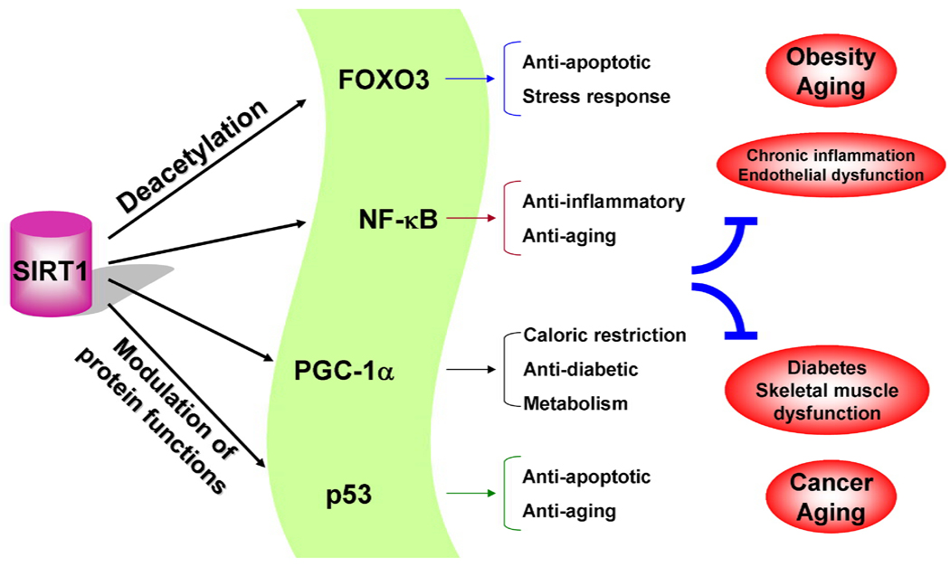
Cells viability ATP method TAXIFOLIN-RICH EXTRACT / Test by Brunswick Laboratories, INC (USA) /
Results: Description |  | Test | Result | Units
TAXIFOLIN E.C. |  | Viability | 990.31 | μg/mL
Cells viability ATP method. The adenosine triphosphate (ATP) luminescence assay is a highly effective method for the quantitative evaluation of proliferation and cytotoxicity of cultured human cells. ATP is a marker for cell viability because it is present in all metabolically active cells and the concentration declines rapidly when the cells undergo necrosis or apoptosis.
The viability result is expressed as the sample concentration which the number of viable cells in culture based on quantitation of the ATP present is the maximum.
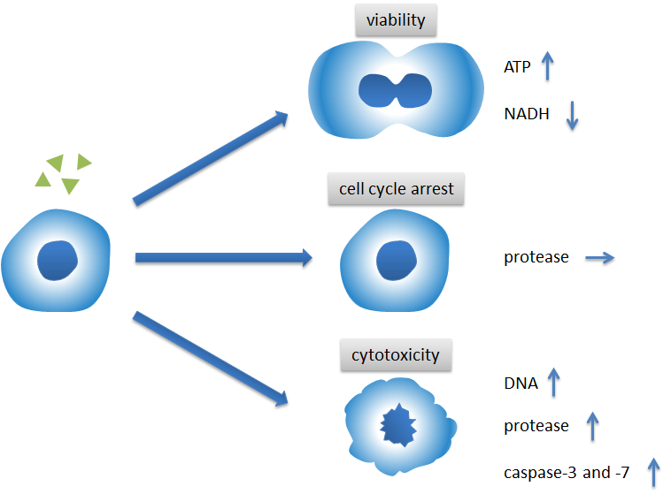
The amount of ATP in cells correlates with cell viability. Within minutes after a loss of membrane integrity, cells lose the ability to synthesize ATP, and endogenous ATPases destroy any remaining ATP; thus the levels of ATP fall precipitously.
Summary table Efficacy cellular system of
TAXIFOLIN-RICH EXTRACT 92% purity assay
(manufacture "Etalon Cosmeticsi", Russian Federation)
Total ORAC_{FN} | 66 946 μmole TE/gram
CAA (Cellular Antioxidant Assay) | 437.77 μmole QE/gram
EC50 (less means more active) | 61.17 µg/mL
Cellular Anti-Inflammatory Assay (NFkB) determines the anti-inflammatory potential of a given material in human cells. NFkB (Nuclear Factor kappa B), a protein complex that is involved in cellular responses to stimuli such as stress and free radicals, is used as inflammation biomarker. | Maximum inhibition - 53.79%  Effective Concentration –  423.98 µg/mL
Cellular Anti-aging Assay (SIRT1) determines the impact of a test material on expression/production level of SIRT1 in human cells. SIRT1 serves as an anti-aging biomarker | Maximum SIRT1 Expression Change (%) 30.4  Effective Concentration  14.8 µg/mL
Cells viability ATP method. The adenosine triphosphate (ATP) luminescence assay is a highly effective method for the quantitative evaluation of proliferation and cytotoxicity of cultured human cells. | Sample concentration corresponds to ATP present is the maximum.  990.31 μg/mL

"Etalon Cosmetics" COMBINES THE TIME HONORED PRACTICES OF EXTRACTING TAXIFOLIN WITH THE MODERN TECHNIQUES OF ANALYSIS, TRACEABILITY, AND THOROUGH QUALITY ASSURANCE.
Certified Quality Management System – ISO 9001 / Certified Food Safety Management System 22000

